Department of Obstetrics and Gynaecology

Name of the Centre:

Case Number:

Vulvoscopy Registration Number: Date:

Name: OPD Number:

W/O: Age

Address: Telephone No:

Parity

Reason for attending Gynae OPD

Any Medical Problem:

Additional cervical or Vaginal Pathology

Indication of Vulvoscopy:

Vulvoscopy

Naked eye examination as per IFCPC 2011 Nomenclature

Three ring vulvoscopy

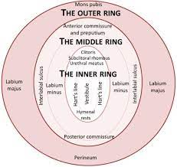

Result as per NSP Scheme:

Vulvoscopy Biopsy advised : Yes/ No

Vulvoscopic Biopsy Report:

Follow up:

Plan:

Consent for Vulvoscopic examination and Vulval Biopsy

Patient Witness Doctor

Done under supervision of :

